Helix

Definition
# Source: AI Source: Provided by: [Data Path: Persons Table -> ID Column: 1, Name_En Column: Motasem Essam] -> From: [ChatGPT] on [7/25/2026]
A Helix is a three-dimensional curve that winds around an imaginary or physical axis while continuously advancing along that axis. It forms a spiral-like path in three-dimensional space.
Unlike a two-dimensional spiral, which lies in a plane, a helix extends through three-dimensional space.
A helix can be formed by combining two simultaneous movements:
- Rotational Movement: Circular motion around an axis.
- Axial Movement: Continuous movement parallel to the axis.
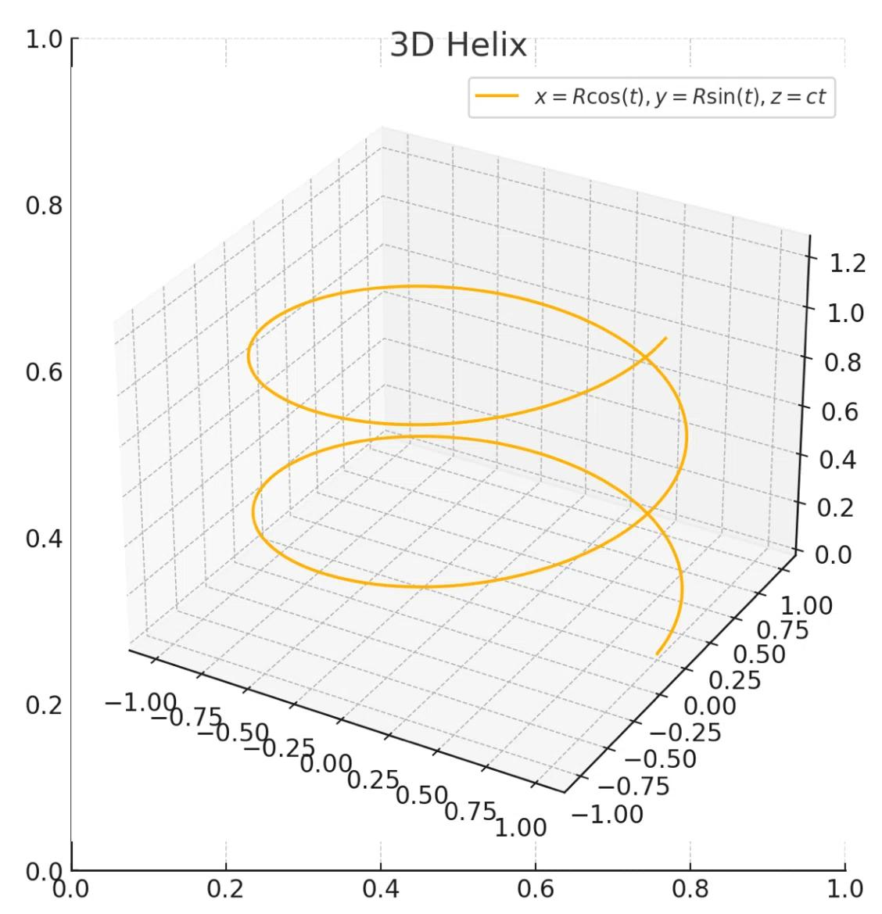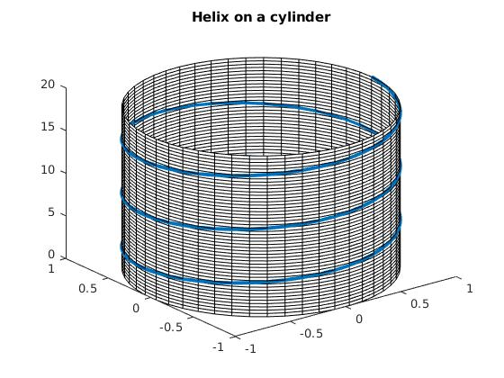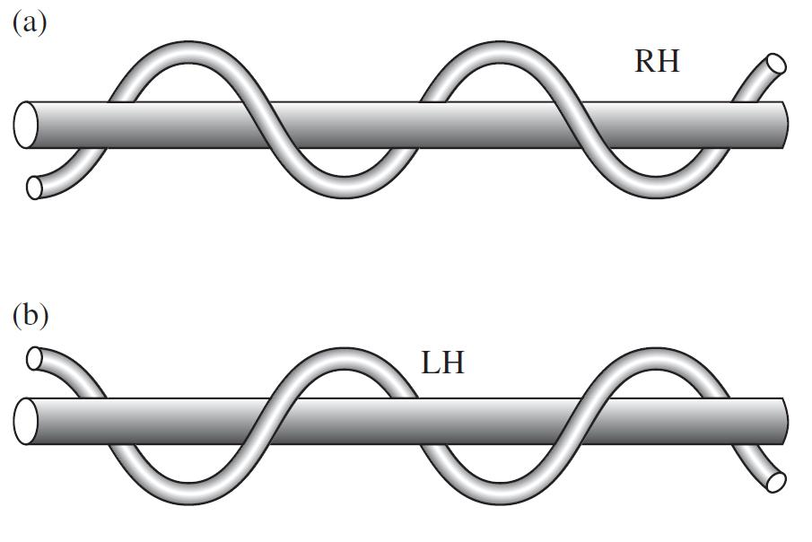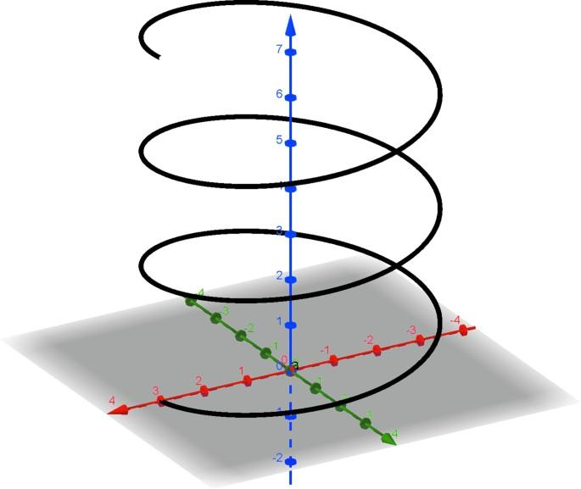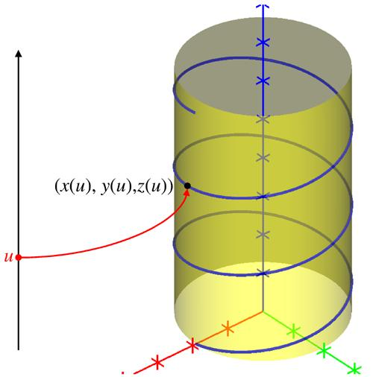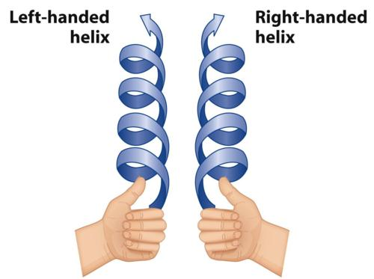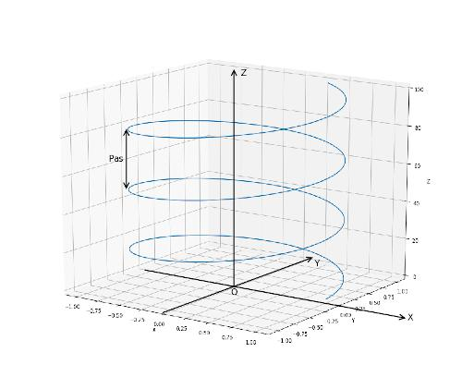

Geometric Structure
# Source: AI Source: Provided by: [Data Path: Persons Table -> ID Column: 1, Name_En Column: Motasem Essam] -> From: [ChatGPT] on [7/25/2026]
A helix consists of several geometric elements:
- Helical Curve: The continuous curved path winding around the axis.
- Axis: The central straight line around which the helix winds.
- Radius: The perpendicular distance from the helix to its axis in a circular helix.
- Pitch: The axial distance covered during one complete revolution.
- Turn: One complete revolution around the axis.
- Helical Angle: The angle between the tangent to the helix and a plane perpendicular to its axis.
- Lead: The axial distance advanced during one complete revolution. For a single-start helix, the lead equals the pitch.
- Height: The total axial length occupied by the helix.
- Number of Turns: The number of complete revolutions around the axis.

Main Characteristics
# Source: AI Source: Provided by: [Data Path: Persons Table -> ID Column: 1, Name_En Column: Motasem Essam] -> From: [ChatGPT] on [7/25/2026]
- A helix is a three-dimensional geometric curve.
- It revolves around a central axis.
- It advances continuously along its axis.
- It can have constant or varying radius.
- It can have constant or varying pitch.
- It may be right-handed or left-handed.
- It can be open-ended or extend through multiple turns.
- Its appearance depends on its radius, pitch, height, and number of turns.

Types and Classification

Based on Geometric Shape

Circular Helix
# Source: AI Source: Provided by: [Data Path: Persons Table -> ID Column: 1, Name_En Column: Motasem Essam] -> From: [ChatGPT] on [7/25/2026]
A helix whose points remain at a constant distance from its straight central axis, producing a cylindrical helical path.
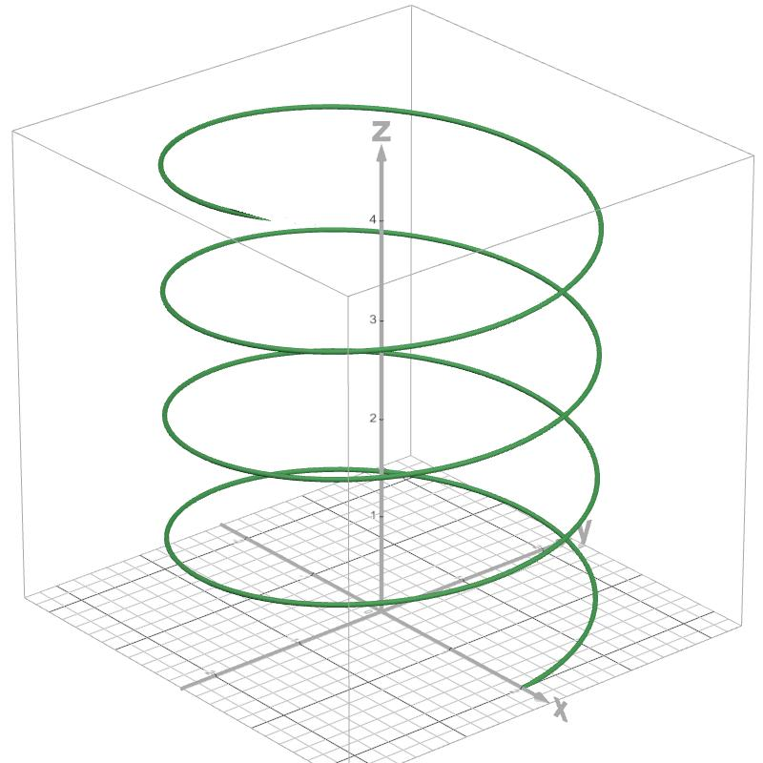

Conical Helix
# Source: AI Source: Provided by: [Data Path: Persons Table -> ID Column: 1, Name_En Column: Motasem Essam] -> From: [ChatGPT] on [7/25/2026]
A helix whose radius changes progressively along its axis, producing a conical spiral path.
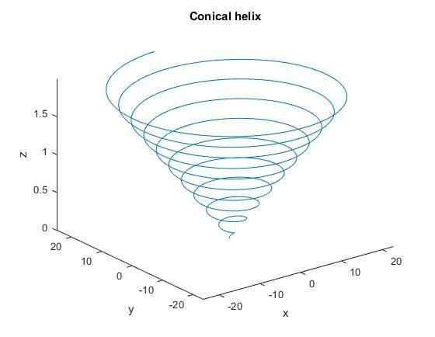

Elliptical Helix
# Source: AI Source: Provided by: [Data Path: Persons Table -> ID Column: 1, Name_En Column: Motasem Essam] -> From: [ChatGPT] on [7/25/2026]
A helical curve whose projection perpendicular to its axis is elliptical rather than circular.
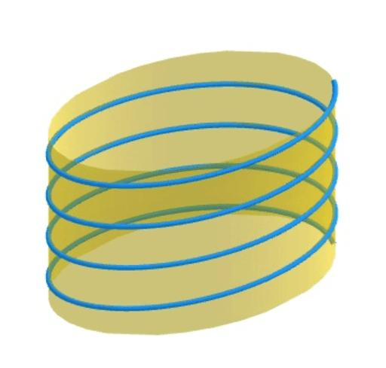

Spherical Helix
# Source: AI Source: Provided by: [Data Path: Persons Table -> ID Column: 1, Name_En Column: Motasem Essam] -> From: [ChatGPT] on [7/25/2026]
A curve that winds around a spherical surface while following a helical-like path.
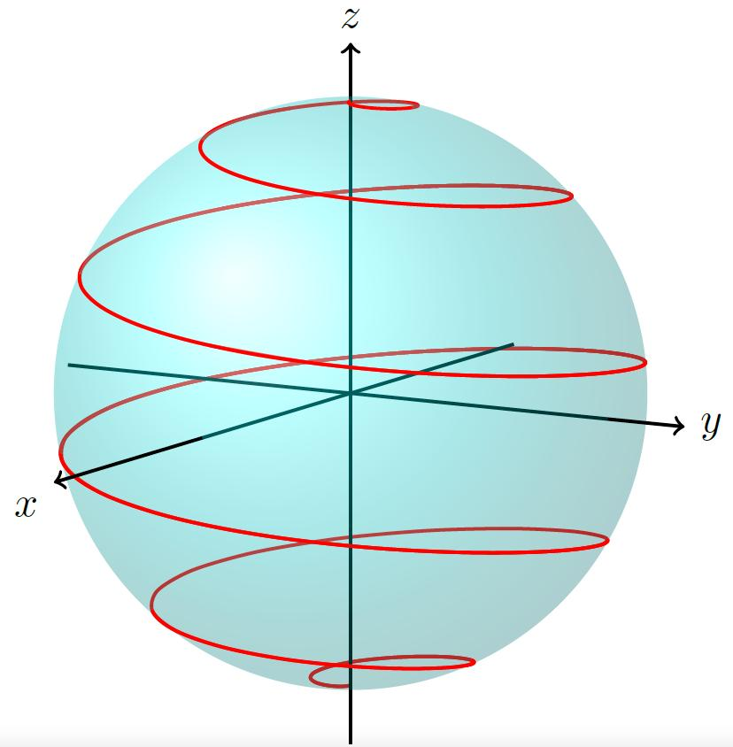

Based on Handedness

Right-Handed Helix
# Source: AI Source: Provided by: [Data Path: Persons Table -> ID Column: 1, Name_En Column: Motasem Essam] -> From: [ChatGPT] on [7/25/2026]
Winds in the right-handed direction around its axis.
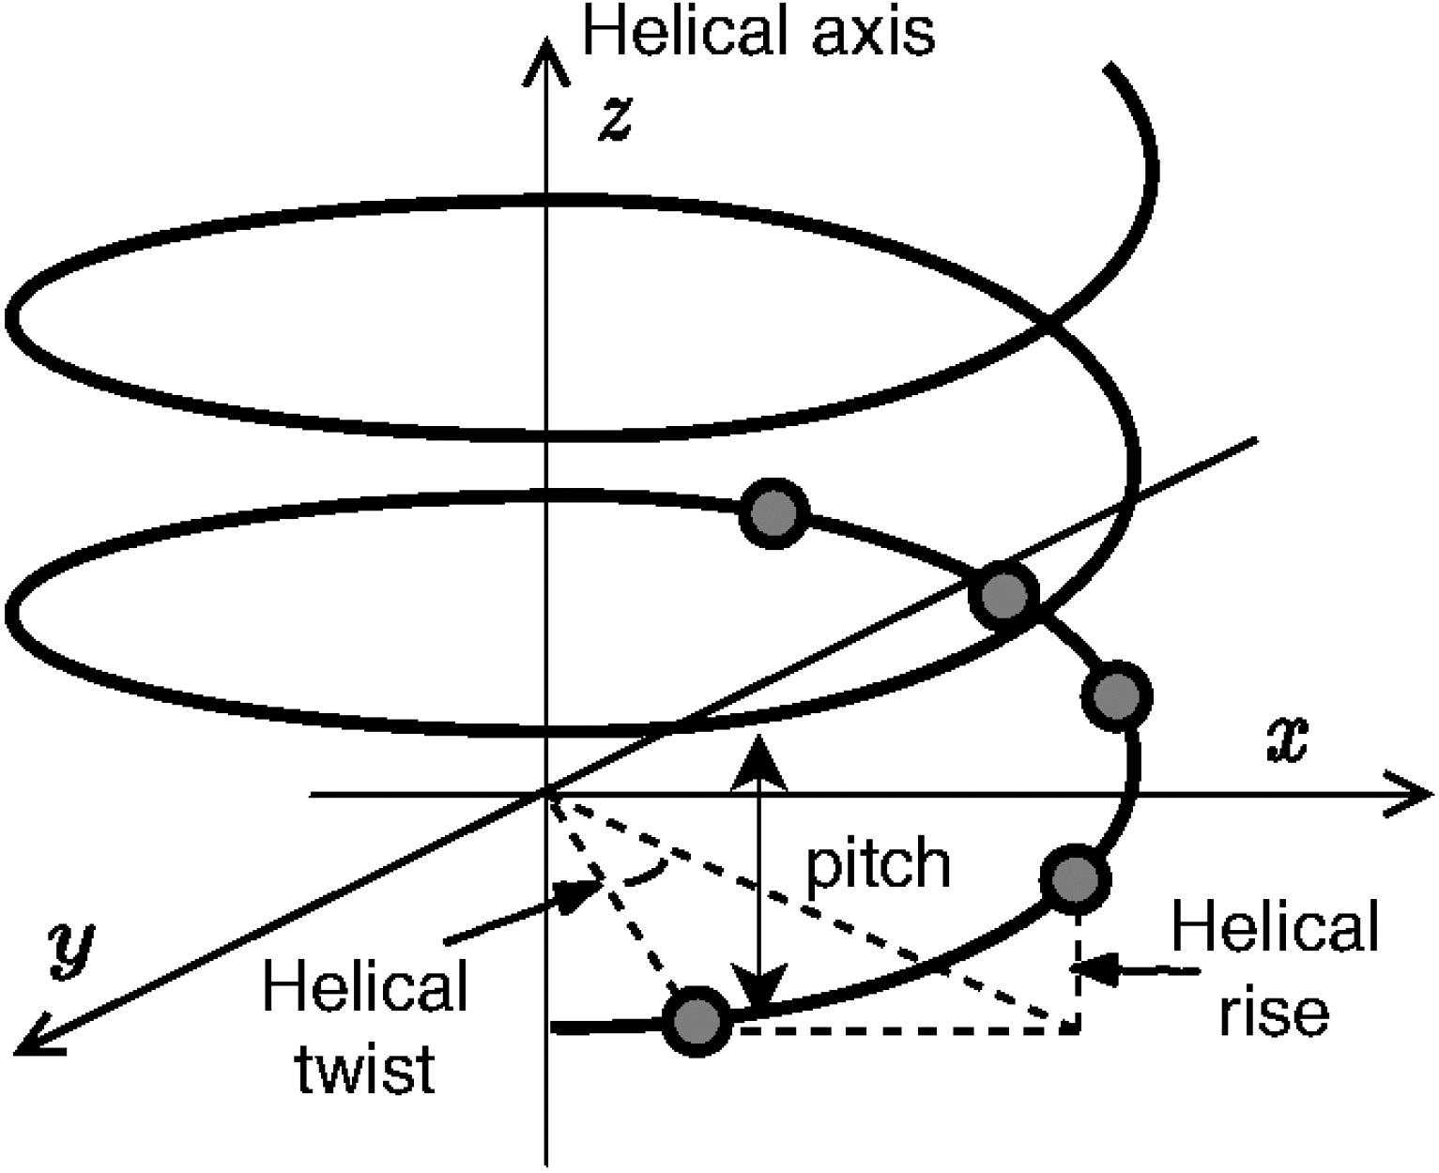

Left-Handed Helix
# Source: AI Source: Provided by: [Data Path: Persons Table -> ID Column: 1, Name_En Column: Motasem Essam] -> From: [ChatGPT] on [7/25/2026]
Winds in the opposite direction around its axis.

Based on Pitch
# Source: AI Source: Provided by: [Data Path: Persons Table -> ID Column: 1, Name_En Column: Motasem Essam] -> From: [ChatGPT] on [7/25/2026]
- Constant-Pitch Helix: Has equal axial advancement during every complete revolution.
- Variable-Pitch Helix: Has changing axial advancement between successive revolutions.

Based on Radius
# Source: AI Source: Provided by: [Data Path: Persons Table -> ID Column: 1, Name_En Column: Motasem Essam] -> From: [ChatGPT] on [7/25/2026]
- Constant-Radius Helix: Maintains the same distance from its axis.
- Variable-Radius Helix: Its distance from the axis changes along its length.

Based on Number of Starts
# Source: AI Source: Provided by: [Data Path: Persons Table -> ID Column: 1, Name_En Column: Motasem Essam] -> From: [ChatGPT] on [7/25/2026]
- Single-Start Helix: Contains one continuous helical path.
- Double-Start Helix: Contains two intertwined helical paths.
- Multiple-Start Helix: Contains three or more intertwined helical paths.

Mathematical Representation

Circular Helix
# Source: AI Source: Provided by: [Data Path: Persons Table -> ID Column: 1, Name_En Column: Motasem Essam] -> From: [ChatGPT] on [7/25/2026]
A standard circular helix can be represented parametrically by:
$$x=rcost$$
$$y=rsint$$
$$z=ct$$
Where:
- $r$ = radius.
- $t$ = angular parameter.
- $c$ = axial advancement per radian.

Pitch
# Source: AI Source: Provided by: [Data Path: Persons Table -> ID Column: 1, Name_En Column: Motasem Essam] -> From: [ChatGPT] on [7/25/2026]
The pitch is the axial distance covered in one complete revolution:
$$P=2πc$$

Height
# Source: AI Source: Provided by: [Data Path: Persons Table -> ID Column: 1, Name_En Column: Motasem Essam] -> From: [ChatGPT] on [7/25/2026]
For a helix with $n$ complete turns and constant pitch:
$$H=nP$$

Helix Length
# Source: AI Source: Provided by: [Data Path: Persons Table -> ID Column: 1, Name_En Column: Motasem Essam] -> From: [ChatGPT] on [7/25/2026]
For a circular helix with constant radius and pitch:
$$L=n\sqrt{(2πr)^{2}+P^{2}}$$
Where:
- $L$ = total curve length.
- $n$ = number of turns.
- $r$ = radius.
- $P$ = pitch.

Constructing a Helix

Geometric Instruments
# Source: AI Source: Provided by: [Data Path: Persons Table -> ID Column: 1, Name_En Column: Motasem Essam] -> From: [ChatGPT] on [7/25/2026]
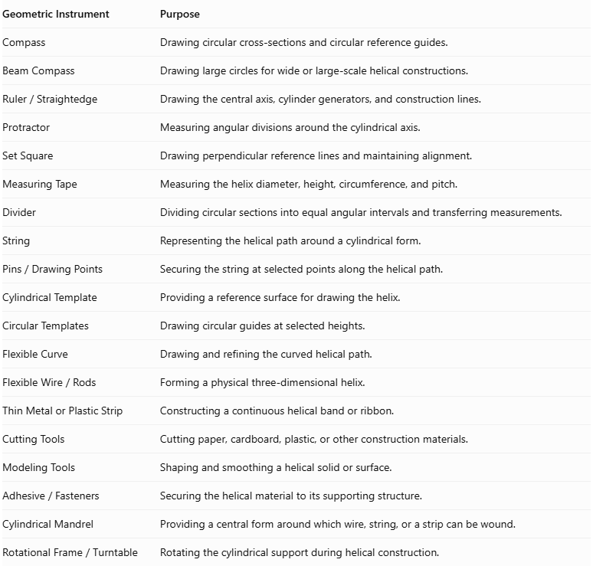
Geometric Instrument | Purpose
Compass | Drawing circular cross-sections and circular reference guides.
Beam Compass | Drawing large circles for wide or large-scale helical constructions.
$$Ruler/Straightedge$$ | Drawing the central axis, cylinder generators, and construction lines.
Protractor | Measuring angular divisions around the cylindrical axis.
Set Square | Drawing perpendicular reference lines and maintaining alignment.
Measuring Tape | Measuring the helix diameter, height, circumference, and pitch.
Divider | Dividing circular sections into equal angular intervals and transferring measurements.
String | Representing the helical path around a cylindrical form.
$$Pins/DrawingPoints$$ | Securing the string at selected points along the helical path.
Cylindrical Template | Providing a reference surface for drawing the helix.
Circular Templates | Drawing circular guides at selected heights.
Flexible Curve | Drawing and refining the curved helical path.
$$FlexibleWire/Rods$$ | Forming a physical three-dimensional helix.
Thin Metal or Plastic Strip | Constructing a continuous helical band or ribbon.
Cutting Tools | Cutting paper, cardboard, plastic, or other construction materials.
Modeling Tools | Shaping and smoothing a helical solid or surface.
$$Adhesive/Fasteners$$ | Securing the helical material to its supporting structure.
Cylindrical Mandrel | Providing a central form around which wire, string, or a strip can be wound.
$$RotationalFrame/Turntable$$ | Rotating the cylindrical support during helical construction.
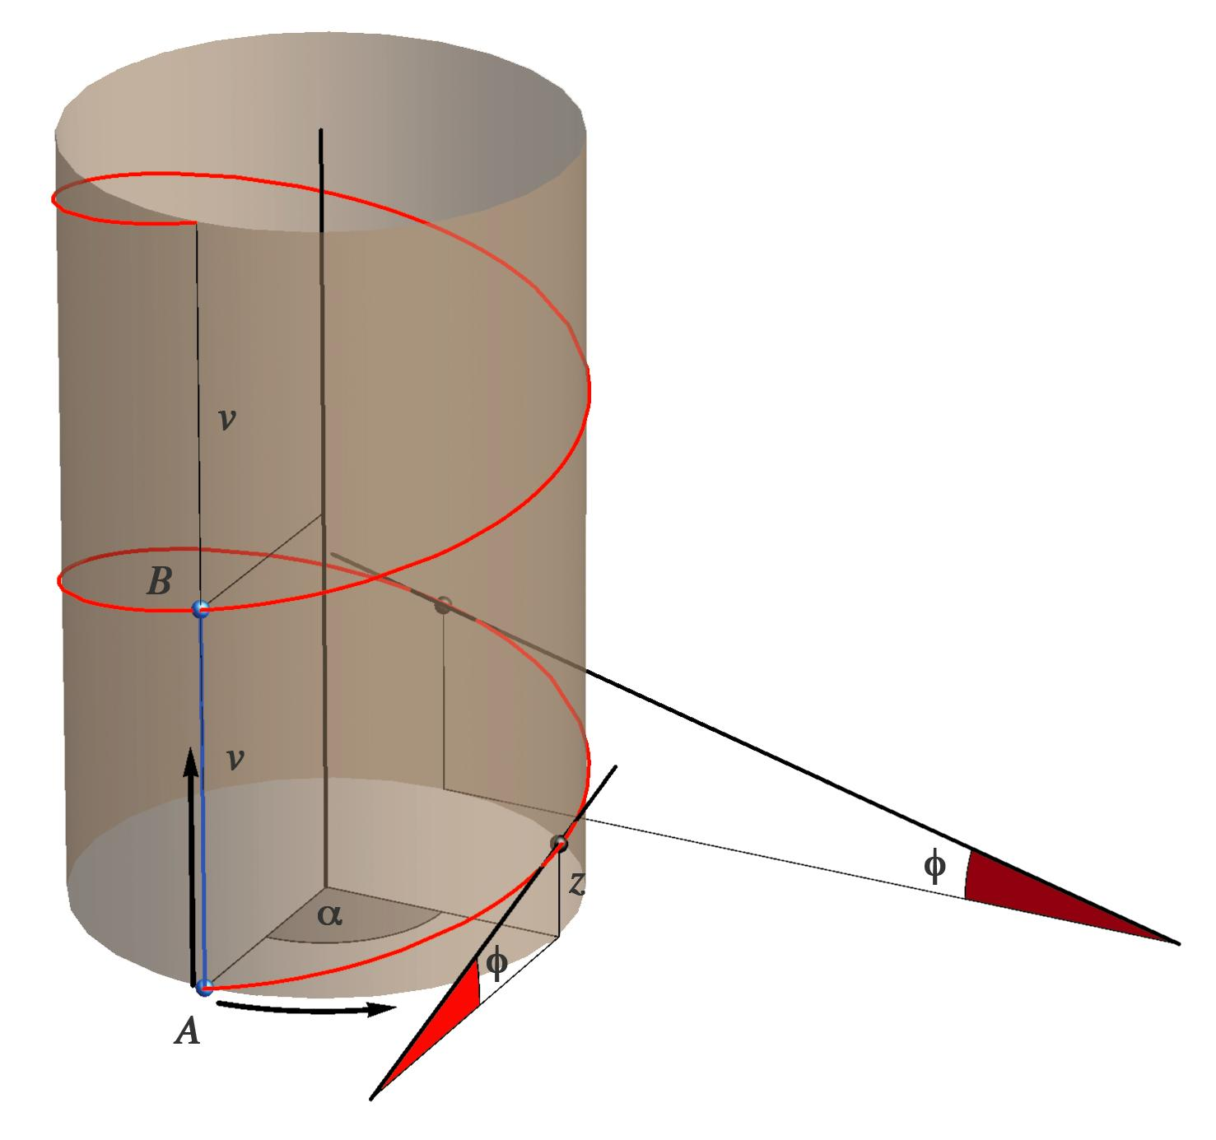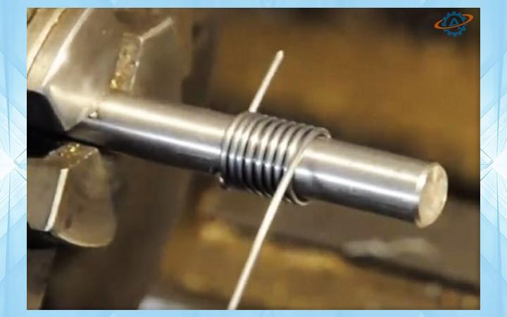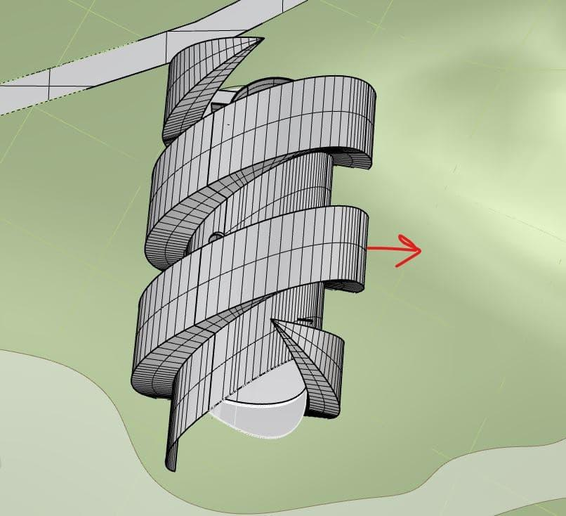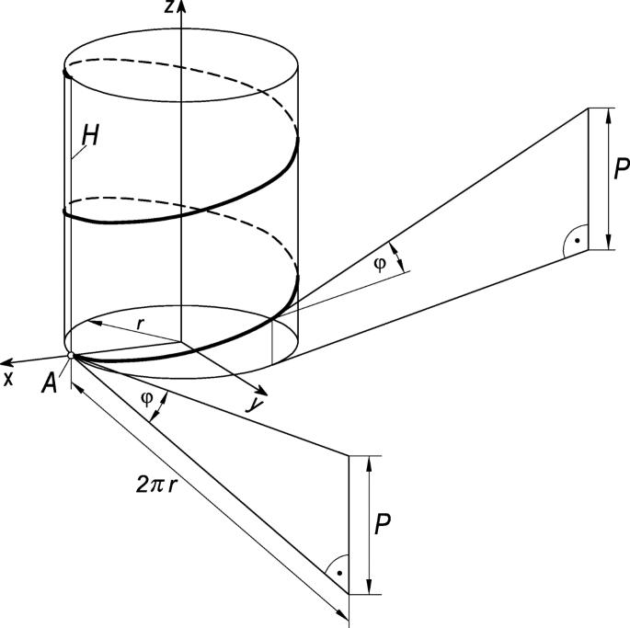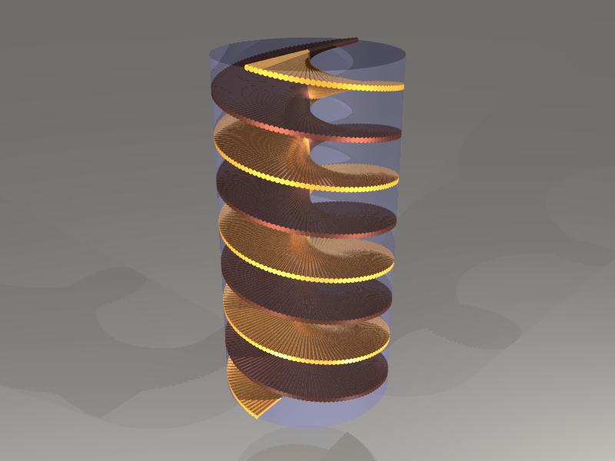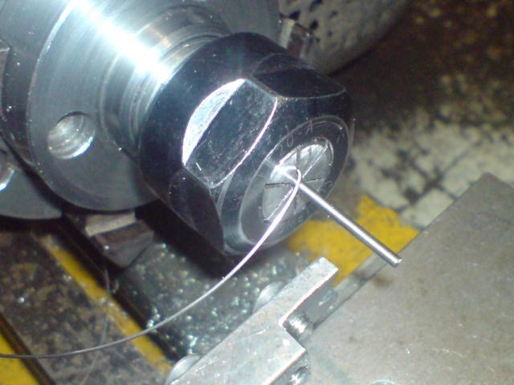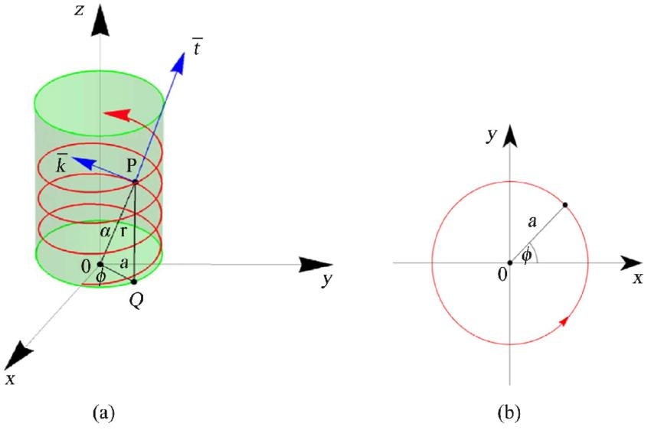

Instrument-Based Construction Procedures

Construction Using Circular Divisions and Vertical Projection (Cylindrical Helix)
# Source: AI Source: Provided by: [Data Path: Persons Table -> ID Column: 1, Name_En Column: Motasem Essam] -> From: [ChatGPT] on [7/25/2026]
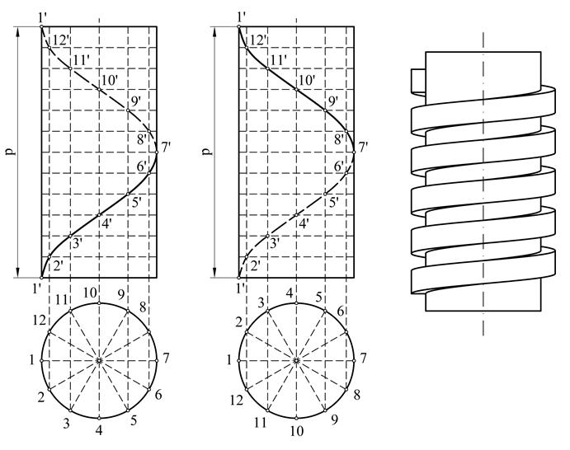
- Draw the front elevation of a cylinder using a ruler, representing its diameter and required height.
- Draw the circular plan of the cylinder using a compass.
- Divide the circular plan into 12 equal angular parts using a protractor or compass.
- Number the divisions consecutively in the chosen rotational direction.
- Divide the required helix pitch into the same number of equal vertical parts.
- Project vertical construction lines from the circular divisions toward the cylinder elevation.
- Draw horizontal construction lines through the corresponding divisions of the pitch.
- Mark the intersections between the vertical and horizontal construction lines.
- Repeat the process for all 12 divisions.
- Join the resulting points using a smooth flexible curve.
- Darken the visible portions of the helix and represent hidden portions with dashed lines when drawing an engineering projection.
This is the standard instrument-based method for constructing a cylindrical helix.

Construction Using a String Wrapped Around a Cylinder
# Source: AI Source: Provided by: [Data Path: Persons Table -> ID Column: 1, Name_En Column: Motasem Essam] -> From: [ChatGPT] on [7/25/2026]
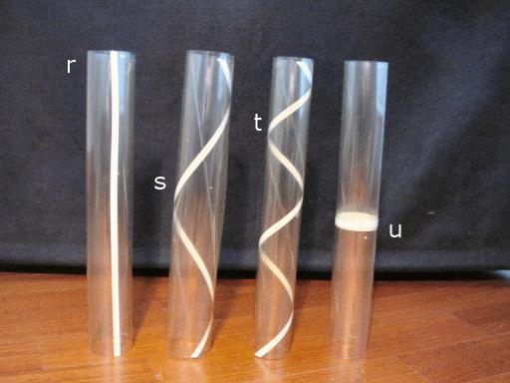
- Prepare a cylindrical tube or solid cylinder.
- Mark the starting point near the lower edge of the cylinder.
- Measure the required pitch using a ruler or measuring tape.
- Mark the corresponding endpoint one complete revolution above the starting point.
- Attach one end of a string to the starting point.
- Wind the string around the cylinder while gradually advancing it upward.
- Maintain a consistent vertical advancement during each revolution.
- Secure the string at the endpoint.
- Inspect the resulting helical path and adjust the string if the pitch is inconsistent.
- Repeat the winding process to produce additional turns.
The string represents the helical curve directly. Its vertical advancement per complete revolution determines the pitch.

Construction Using a Developed Rectangular Surface
# Source: AI Source: Provided by: [Data Path: Persons Table -> ID Column: 1, Name_En Column: Motasem Essam] -> From: [ChatGPT] on [7/25/2026]
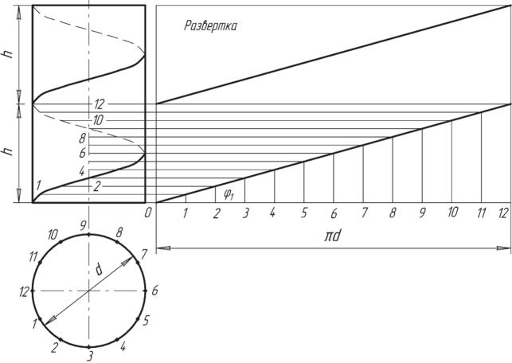
- Prepare a cylindrical tube and measure its diameter.
- Calculate or measure its circumference:
$$C=2πr=πD$$
- Cut a rectangular sheet whose width equals the cylinder circumference.
- Set the rectangle's height equal to the required pitch for one complete turn.
- Draw a diagonal line from one corner of the rectangle to the opposite corner.
- Divide the rectangle's width into 12 equal parts.
- Divide its height into 12 equal parts.
- Mark corresponding points along the diagonal.
- Wrap the sheet around the cylinder, aligning its vertical edges.
- Transfer the diagonal line onto the cylindrical surface.
- Remove the sheet to inspect the resulting helical path.
The developed helix becomes a straight diagonal line on the unwrapped rectangular surface.

Construction Using Flexible Wire Around a Cylindrical Mandrel
# Source: AI Source: Provided by: [Data Path: Persons Table -> ID Column: 1, Name_En Column: Motasem Essam] -> From: [ChatGPT] on [7/25/2026]
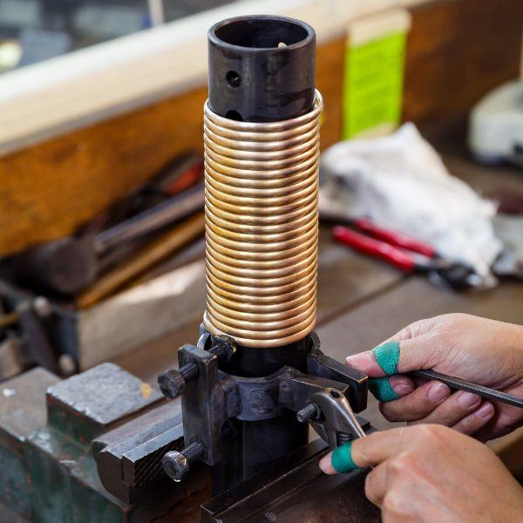
- Select a cylindrical mandrel with the required diameter.
- Mark the starting position along the mandrel.
- Measure and mark the required pitch using a ruler.
- Secure one end of a flexible wire to the starting position.
- Bend the wire around the mandrel while gradually advancing it along the cylinder.
- Maintain equal spacing between successive turns.
- Continue winding until the required number of revolutions is completed.
- Secure the final end of the wire.
- Remove the wire carefully from the mandrel.
- Inspect the resulting helix for consistent diameter, pitch, and spacing.
This method is suitable for constructing physical helical curves and cylindrical coil structures.

Construction Using a Flexible Plastic or Cardboard Strip
# Source: AI Source: Provided by: [Data Path: Persons Table -> ID Column: 1, Name_En Column: Motasem Essam] -> From: [ChatGPT] on [7/25/2026]
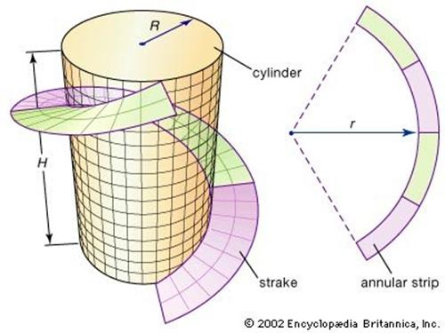
- Prepare a cylindrical support with the required diameter.
- Cut a long, narrow strip of flexible cardboard or plastic.
- Mark a starting point near the lower end of the cylinder.
- Determine the required pitch and mark the corresponding vertical advancement.
- Attach one end of the strip to the cylinder.
- Wrap the strip around the cylinder while gradually moving upward.
- Maintain consistent spacing between successive turns.
- Secure the strip at the final position using adhesive.
- Adjust the strip to obtain a regular helical arrangement.
- Remove the support if a self-supporting helical ribbon is required.
This method produces a visible helical band rather than only a thin helical curve.

Construction of a Helical Spring
# Source: AI Source: Provided by: [Data Path: Persons Table -> ID Column: 1, Name_En Column: Motasem Essam] -> From: [ChatGPT] on [7/25/2026]
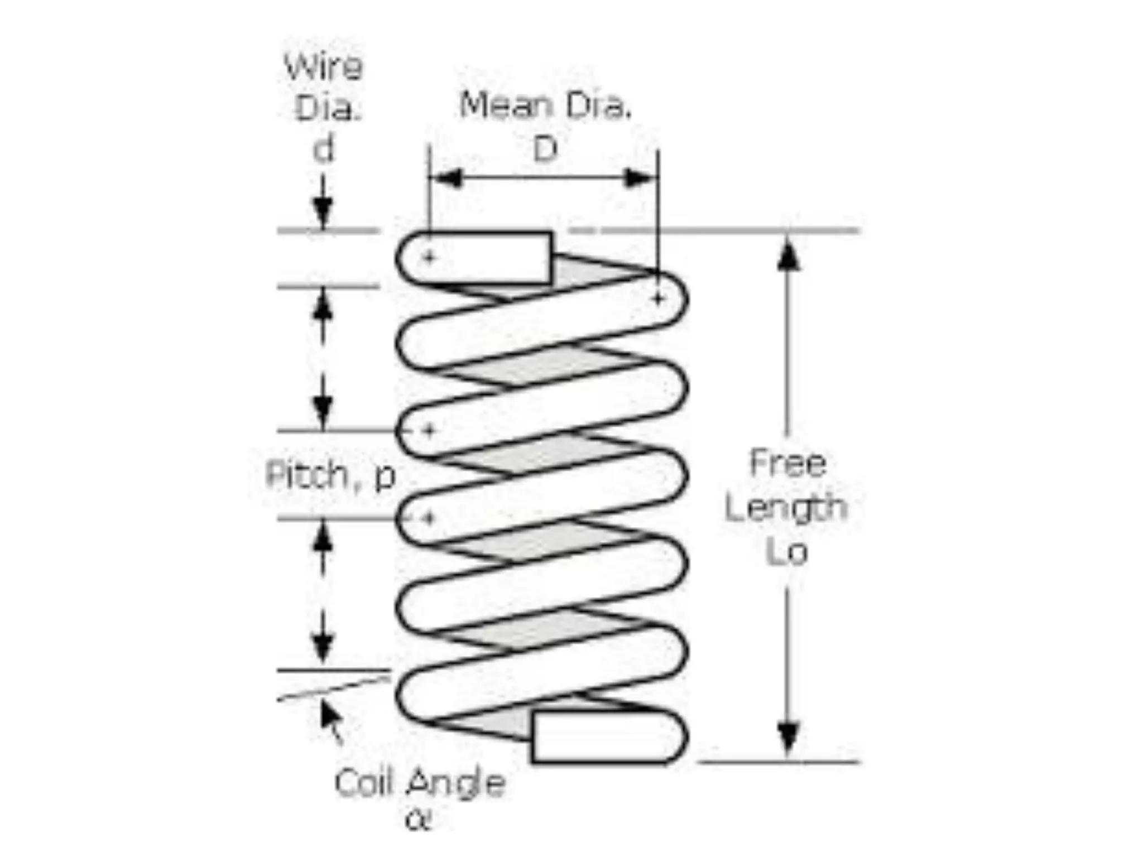
- Select the required outside diameter, wire thickness, pitch, and total number of turns.
- Prepare a cylindrical mandrel with a diameter appropriate for the spring.
- Mark the required pitch along the mandrel.
- Secure the starting end of the wire.
- Wind the wire around the mandrel while advancing it uniformly.
- Maintain the specified distance between successive turns.
- Continue winding until the required number of turns is obtained.
- Cut the wire and secure its final end.
- Remove the spring from the mandrel.
- Adjust the end turns and inspect the spring's diameter and pitch.
A helical spring is a physical application of a cylindrical helix. Its wire has a finite cross-section, unlike an ideal mathematical helical curve.

Construction of a Conical Helix
# Source: AI Source: Provided by: [Data Path: Persons Table -> ID Column: 1, Name_En Column: Motasem Essam] -> From: [ChatGPT] on [7/25/2026]
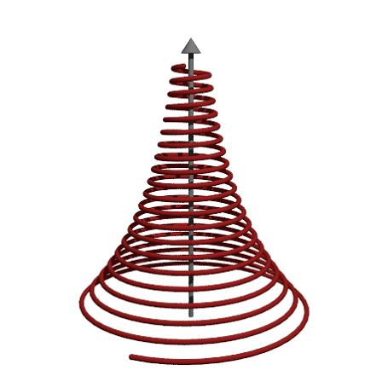
- Draw the front elevation of a cone using a ruler and compass.
- Draw its circular base using a compass.
- Mark the central axis of the cone.
- Divide the circular base into 12 equal angular parts.
- Mark the required number of vertical divisions along the cone's height.
- Project the angular divisions toward the front elevation.
- Determine the corresponding positions along the cone's sloping generators.
- Mark the intersections that define the helical path.
- Join the points with a smooth flexible curve.
- Alternatively, wind a flexible wire around a conical mandrel, gradually changing its distance from the cone's axis.
- Check that the resulting curve follows the conical surface.
A conical helix differs from a cylindrical helix because its distance from the central axis changes along its length.

Construction Using a Rotational Frame
# Source: AI Source: Provided by: [Data Path: Persons Table -> ID Column: 1, Name_En Column: Motasem Essam] -> From: [ChatGPT] on [7/25/2026]
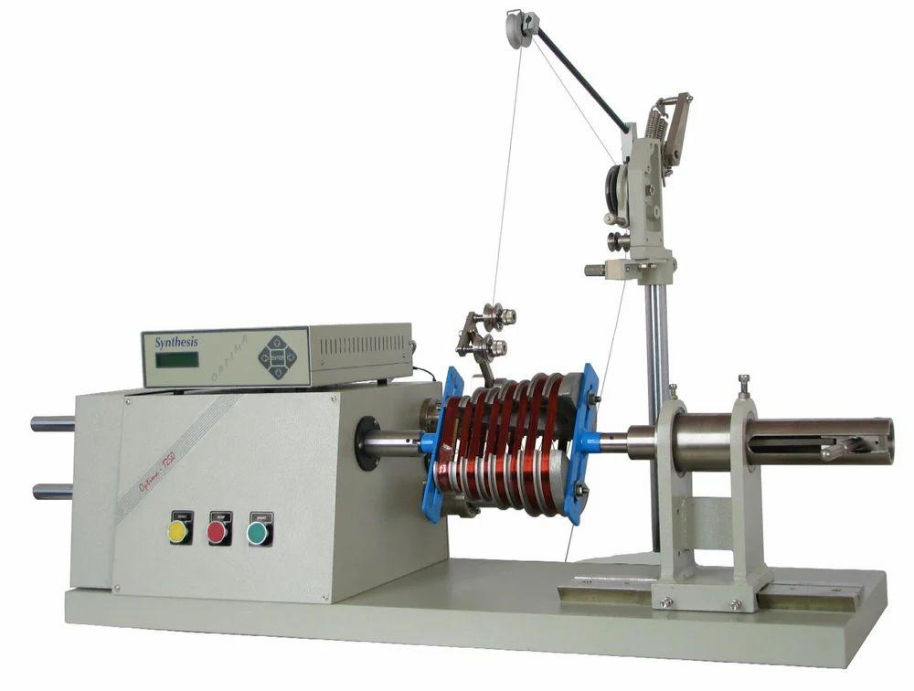
- Prepare a cylindrical mandrel and mount it on a rotational frame.
- Set the mandrel's axis parallel to the direction of the wire or strip feed.
- Mark the required pitch and number of turns.
- Secure the starting end of the material to the mandrel.
- Rotate the mandrel while gradually moving the material along its axis.
- Adjust the rotational movement and axial advancement to maintain a constant pitch.
- Continue until the required helix length is achieved.
- Stop the rotation and secure the final end.
- Remove the completed helix carefully.
- Inspect its turns, pitch, diameter, and handedness.
This method is useful for constructing regular helices and producing repeated helical components.

Geometric Construction Notes
# Source: AI Source: Provided by: [Data Path: Persons Table -> ID Column: 1, Name_En Column: Motasem Essam] -> From: [ChatGPT] on [7/25/2026]

Main geometric properties
# Source: AI Source: Provided by: [Data Path: Persons Table -> ID Column: 1, Name_En Column: Motasem Essam] -> From: [ChatGPT] on [7/25/2026]
- Helix: A three-dimensional curve that winds around an axis while advancing along it.
- Pitch: The axial distance advanced during one complete revolution.
- Radius: The distance from the helical curve to the central axis for a cylindrical helix.
- Handedness: Determines whether the helix is right-handed or left-handed.
- Number of Turns: The number of complete revolutions around the axis.

Supporting formulas
# Source: AI Source: Provided by: [Data Path: Persons Table -> ID Column: 1, Name_En Column: Motasem Essam] -> From: [ChatGPT] on [7/25/2026]
For a cylindrical helix:
$$C=2πr=πD$$
$$L_{\text{one turn}}=\sqrt{(2πr)^{2}+p^{2}}$$
Where:
- $r$ = cylinder radius.
- $D$ = cylinder diameter.
- $p$ = pitch.
- $L_{\text{one turn}}$ = length of one complete helical turn.
For $n$ complete turns, the total axial height is:
$$H=np$$

Types of Helix
# Source: AI Source: Provided by: [Data Path: Persons Table -> ID Column: 1, Name_En Column: Motasem Essam] -> From: [ChatGPT] on [7/25/2026]
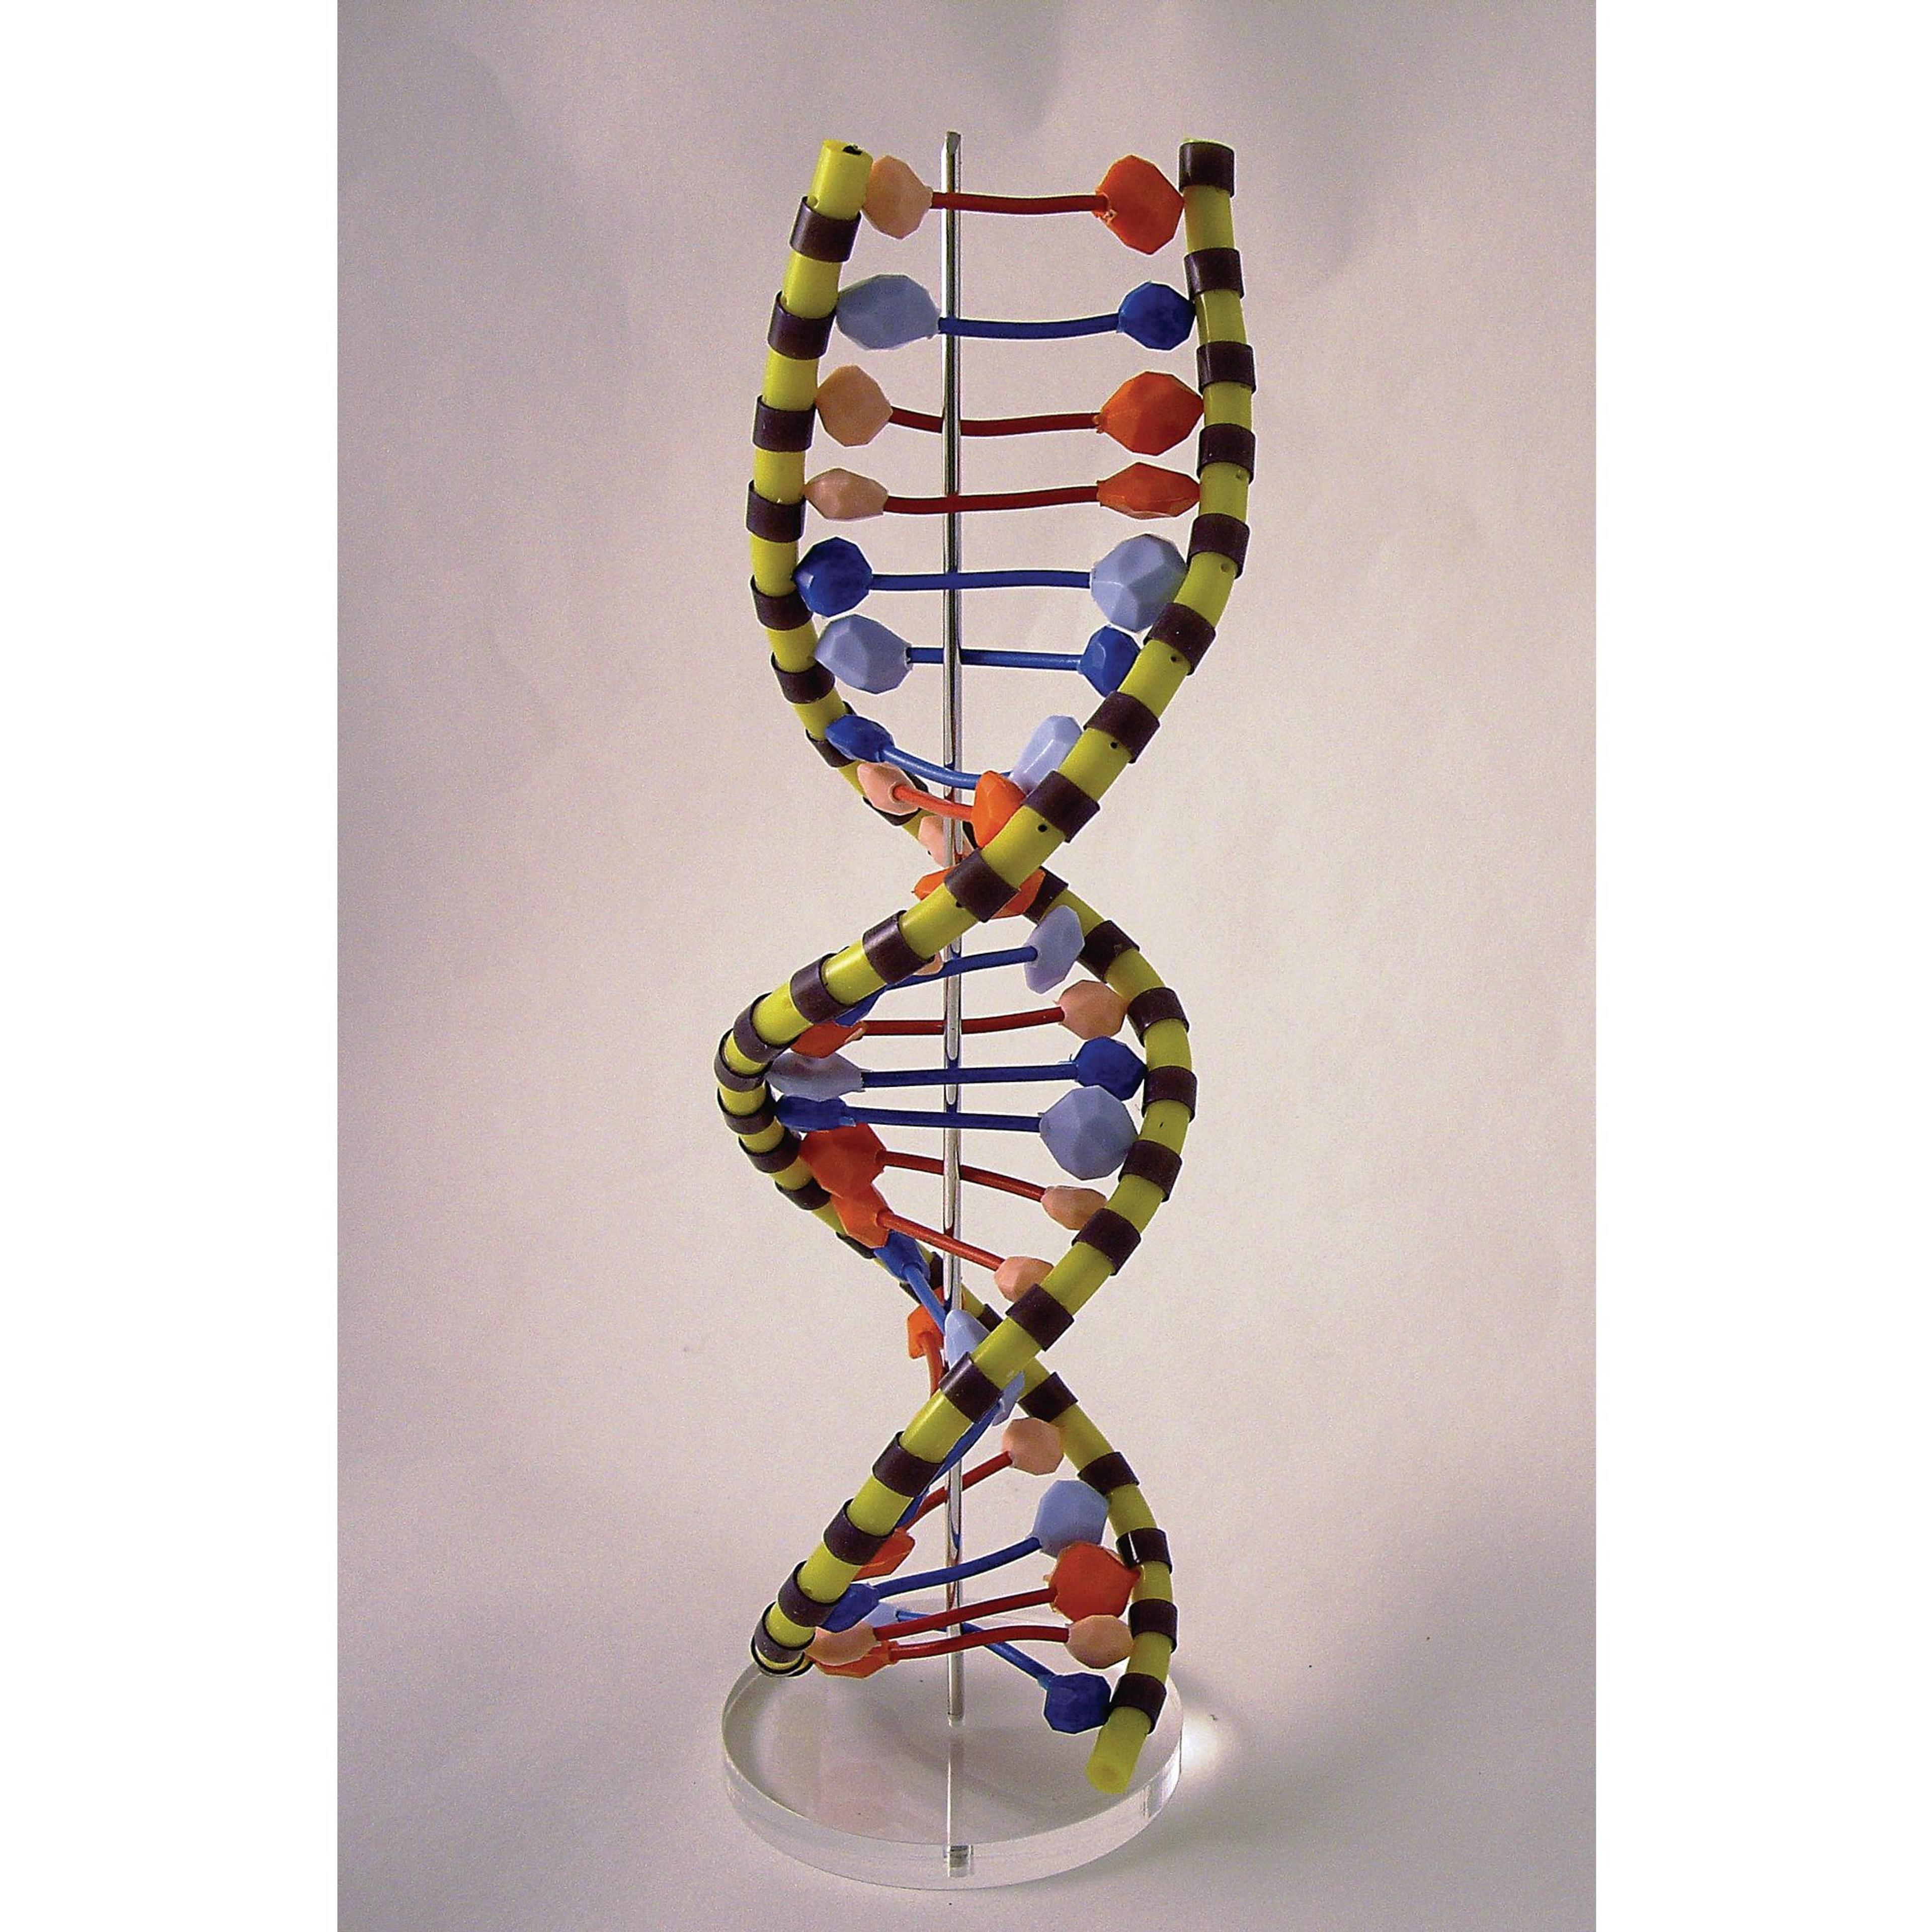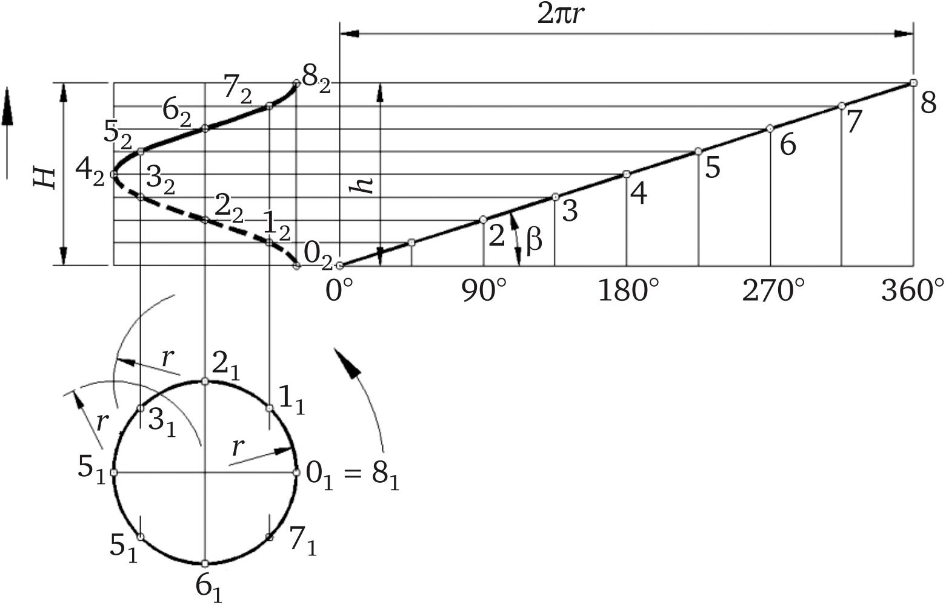
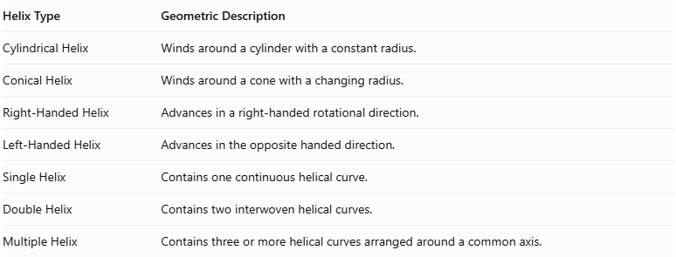
Helix Type | Geometric Description
Cylindrical Helix | Winds around a cylinder with a constant radius.
Conical Helix | Winds around a cone with a changing radius.
Right-Handed Helix | Advances in a right-handed rotational direction.
Left-Handed Helix | Advances in the opposite handed direction.
Single Helix | Contains one continuous helical curve.
Double Helix | Contains two interwoven helical curves.
Multiple Helix | Contains three or more helical curves arranged around a common axis.
Construction Note: These procedures use geometric instruments, cylindrical and conical templates, physical winding, surface development, and rotational mechanisms. They do not use coordinate-based construction.

Comparison with Related Geometric Forms
# Source: AI Source: Provided by: [Data Path: Persons Table -> ID Column: 1, Name_En Column: Motasem Essam] -> From: [ChatGPT] on [7/25/2026]
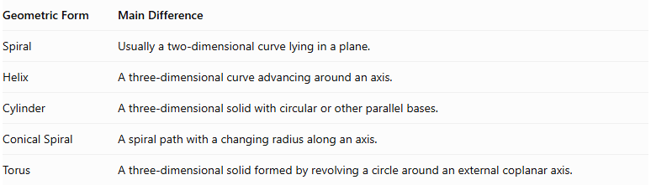
Geometric Form | Main Difference
Spiral | Usually a two-dimensional curve lying in a plane.
Helix | A three-dimensional curve advancing around an axis.
Cylinder | A three-dimensional solid with circular or other parallel bases.
Conical Spiral | A spiral path with a changing radius along an axis.
Torus | A three-dimensional solid formed by revolving a circle around an external coplanar axis.

Applications
# Source: AI Source: Provided by: [Data Path: Persons Table -> ID Column: 1, Name_En Column: Motasem Essam] -> From: [ChatGPT] on [7/25/2026]
- Springs and mechanical components.
- Screw threads and bolts.
- DNA double-helix structures.
- Staircase and architectural designs.
- Helical gears and mechanical systems.
- Antennas and electromagnetic applications.
- Coiled cables and tubes.
- Mathematical modeling and three-dimensional graphics.
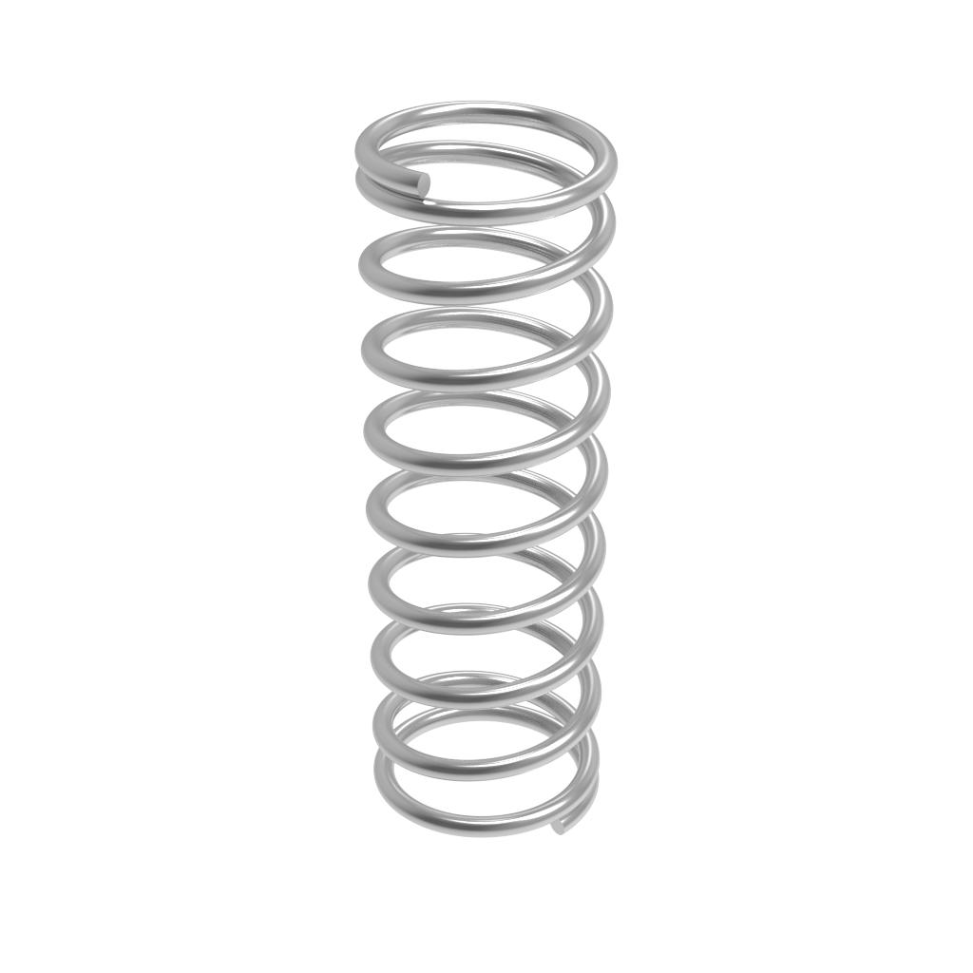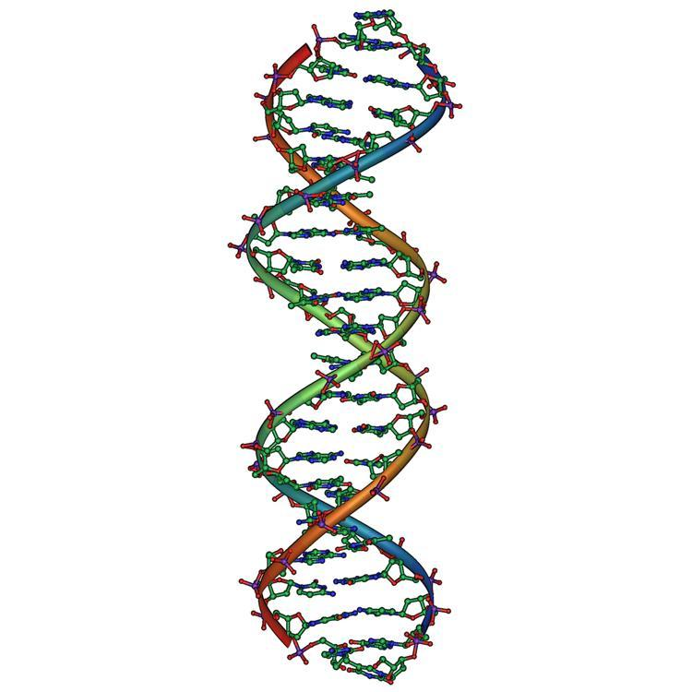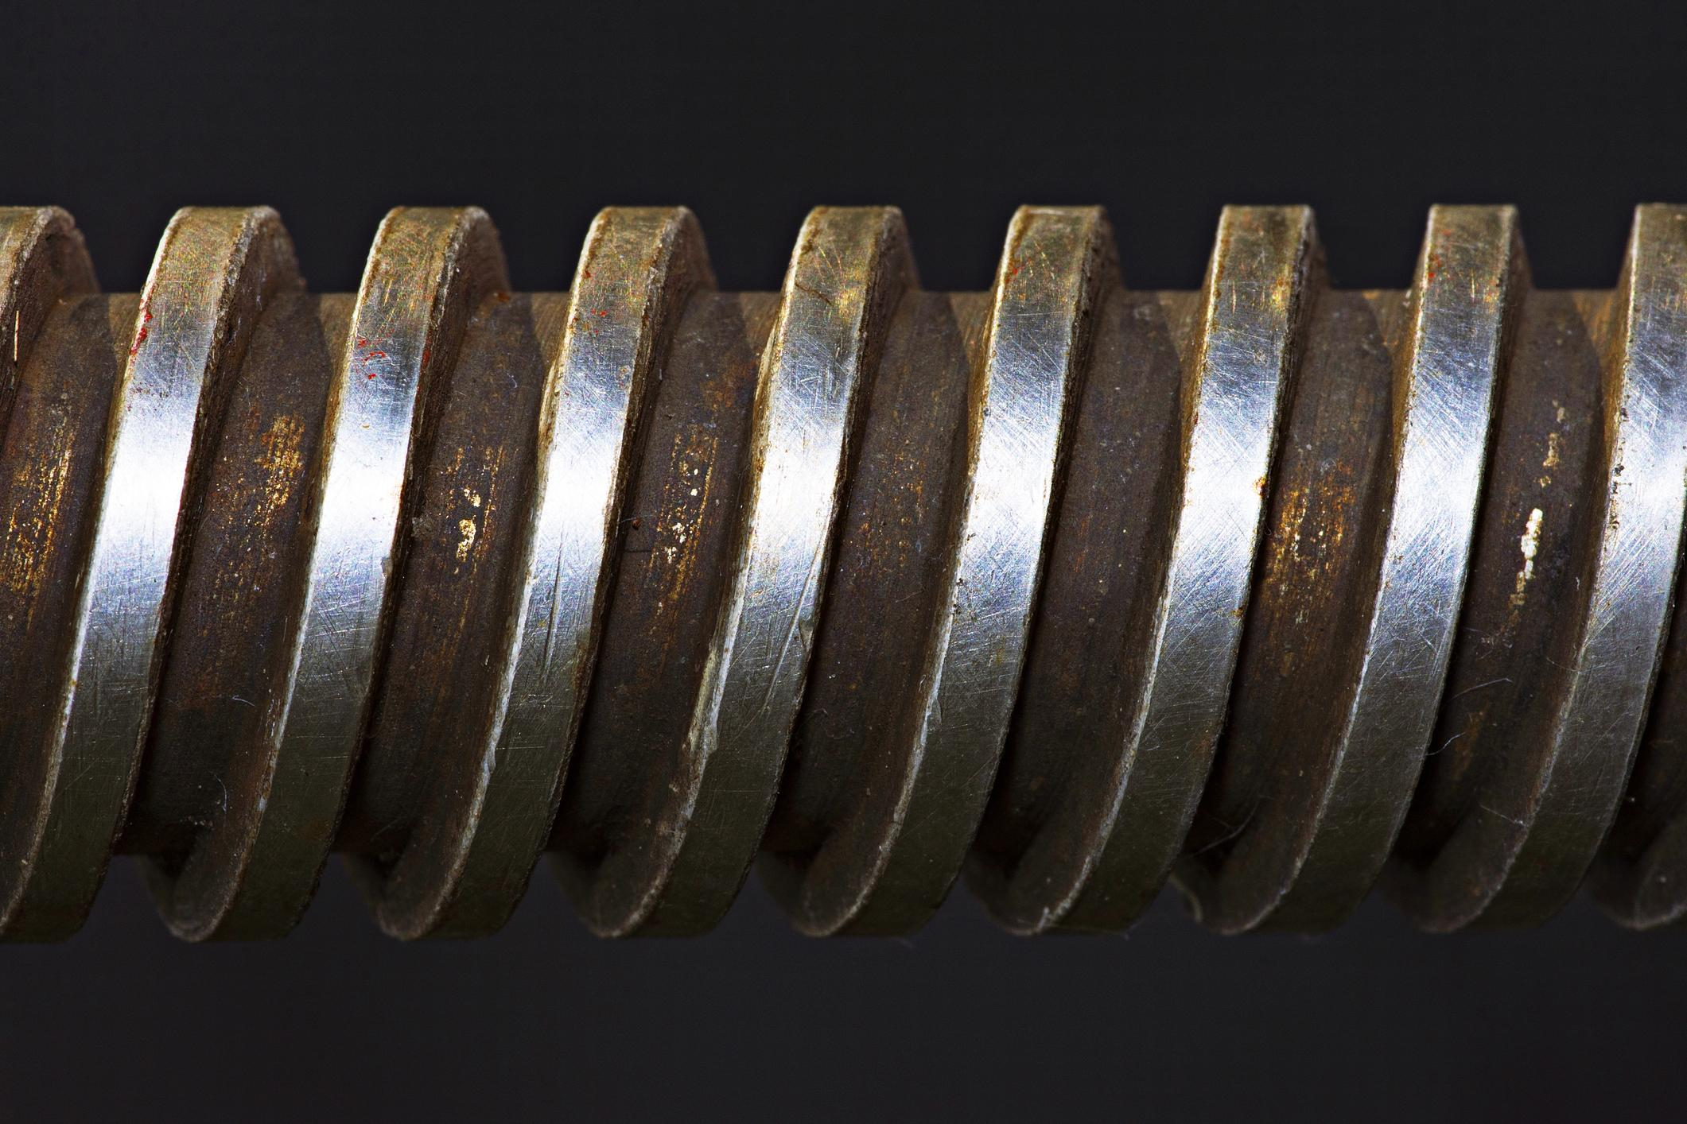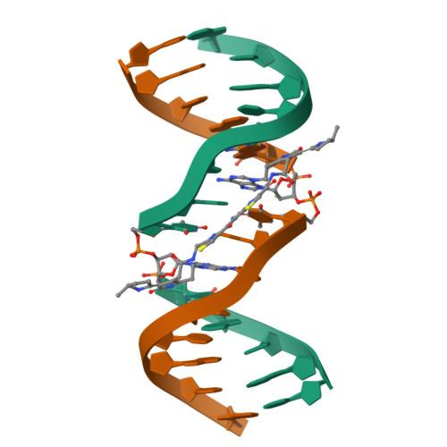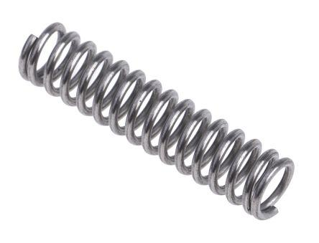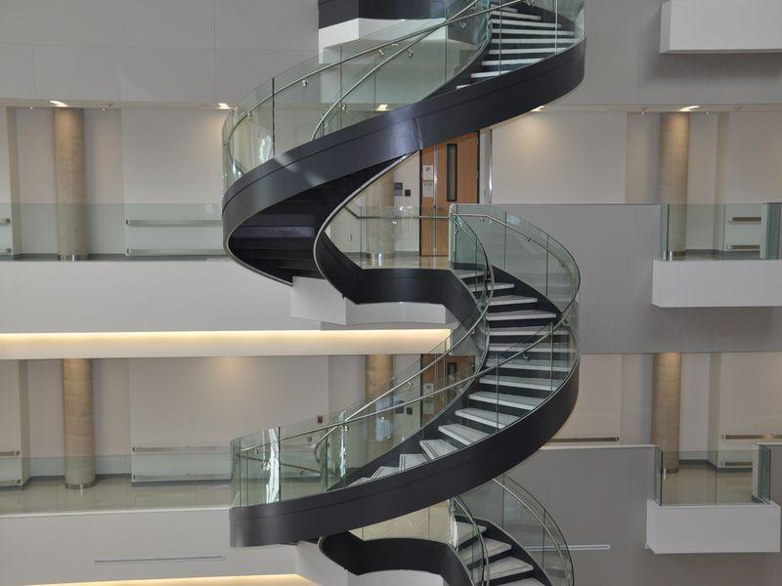

Main Classification
# Source: AI Source: Provided by: [Data Path: Persons Table -> ID Column: 1, Name_En Column: Motasem Essam] -> From: [ChatGPT] on [7/25/2026]
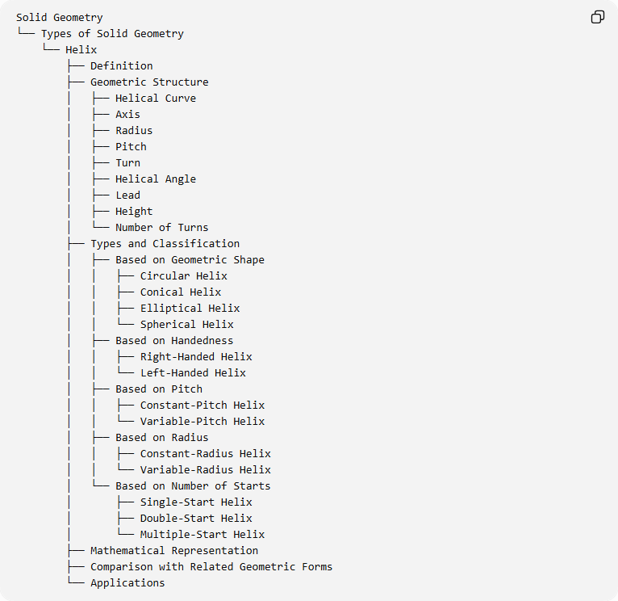
Solid Geometry
└── Types of Solid Geometry
└── Helix
├── Definition
├── Geometric Structure
│ ├── Helical Curve
│ ├── Axis
│ ├── Radius
│ ├── Pitch
│ ├── Turn
│ ├── Helical Angle
│ ├── Lead
│ ├── Height
│ └── Number of Turns
├── Types and Classification
│ ├── Based on Geometric Shape
│ │ ├── Circular Helix
│ │ ├── Conical Helix
│ │ ├── Elliptical Helix
│ │ └── Spherical Helix
│ ├── Based on Handedness
│ │ ├── Right-Handed Helix
│ │ └── Left-Handed Helix
│ ├── Based on Pitch
│ │ ├── Constant-Pitch Helix
│ │ └── Variable-Pitch Helix
│ ├── Based on Radius
│ │ ├── Constant-Radius Helix
│ │ └── Variable-Radius Helix
│ └── Based on Number of Starts
│ ├── Single-Start Helix
│ ├── Double-Start Helix
│ └── Multiple-Start Helix
├── Mathematical Representation
├── Comparison with Related Geometric Forms
└── Applications

Key Points
# Source: AI Source: Provided by: [Data Path: Persons Table -> ID Column: 1, Name_En Column: Motasem Essam] -> From: [ChatGPT] on [7/25/2026]
- A helix is a three-dimensional curve, not a solid by itself.
- It winds around an axis while advancing along that axis.
- Its principal geometric properties include radius, pitch, height, and number of turns.
- Circular helices have constant radius, while other helical forms may have changing radii.
- Helices can be right-handed or left-handed.
- Helices are widely used in mathematics, engineering, architecture, and molecular biology.

Conclusion
# Source: AI Source: Provided by: [Data Path: Persons Table -> ID Column: 1, Name_En Column: Motasem Essam] -> From: [ChatGPT] on [7/25/2026]
A Helix is an important three-dimensional geometric curve characterized by its rotational and axial movement. Its different forms, including circular, conical, and elliptical helices, provide useful geometric models for natural structures and engineering applications.
I can also prepare a separate classification of Helical Solids, distinguishing the three-dimensional solids formed around or along helical paths from the helix curve itself.

